**EXPERIMENT NO 2**

**PART A:**

**SOURCE CODE:**

import java.util.*;

class pattern

{

public static void main(String args[])

{

Scanner sc= new Scanner(System.in);

System.out.println("Enter the number of lines");

int n=sc.nextInt();

for(int i=1;i<=n;i++)

{ for(int j=1;j<i;j++)

System.out.print(" ");

for(int k=1;k<n+1-i;k++)

System.out.print((char)(k+64));

for(int h=n+1-i;h>0;h--)

System.out.print((char)(h+64));

System.out.println("");

}

}

}

**OUTPUT:**

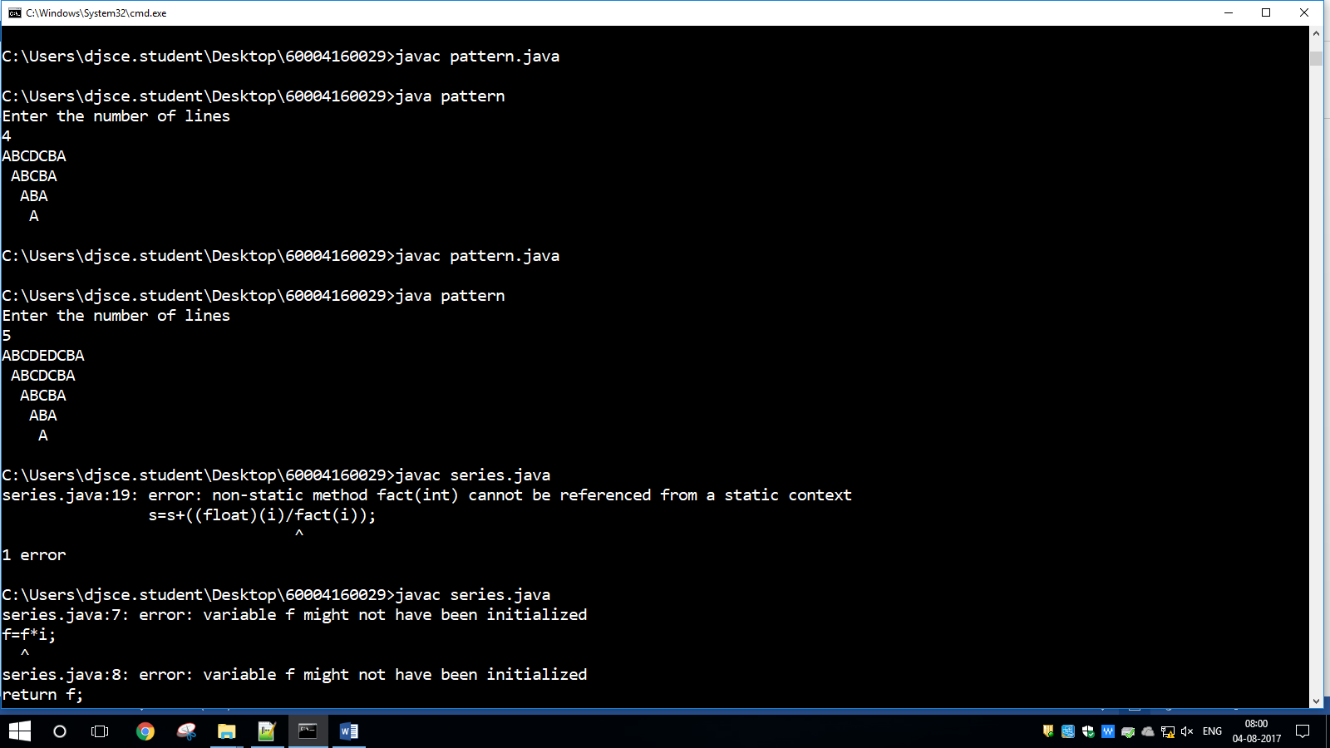

**PART B:**

**SOURCE CODE:**

import java.util.*;

class series

{

public static int fact(int x)

{

int f=1;

for(int i=1;i<=x;i++)

f=f*i;

return f;

}

public static void main(String args[])

{

Scanner sc= new Scanner(System.in);

System.out.println("Enter the number of terms");

int n=sc.nextInt();float s=0;

for(int i=1;i<=n;i++)

{

s=s+((float)(i)/fact(i));

}

System.out.println(s);

}

}

**OUTPUT:**

